**Query String**

Step 1: Download Library.zip file and save it in htdocs under Xampp

Step 2: Copy the following script (library.sql) and run it in Xampp Shell

CREATE DATABASE library;

USE library;

--

-- Table structure for table `book`

--

CREATE TABLE `book` (

`bookid` bigint(20) UNSIGNED AUTO_INCREMENT PRIMARY KEY,

`title` varchar(40) DEFAULT NULL,

`author` varchar(40) DEFAULT NULL,

`genre` varchar(30) DEFAULT NULL,

`published` year(4) DEFAULT NULL,

`description` text DEFAULT NULL

) ENGINE=InnoDB DEFAULT CHARSET=utf8mb4;

Step 3: Run your Library project

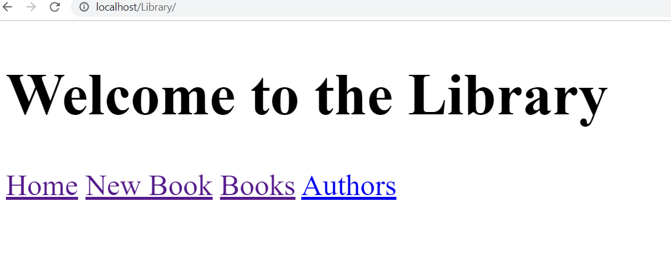

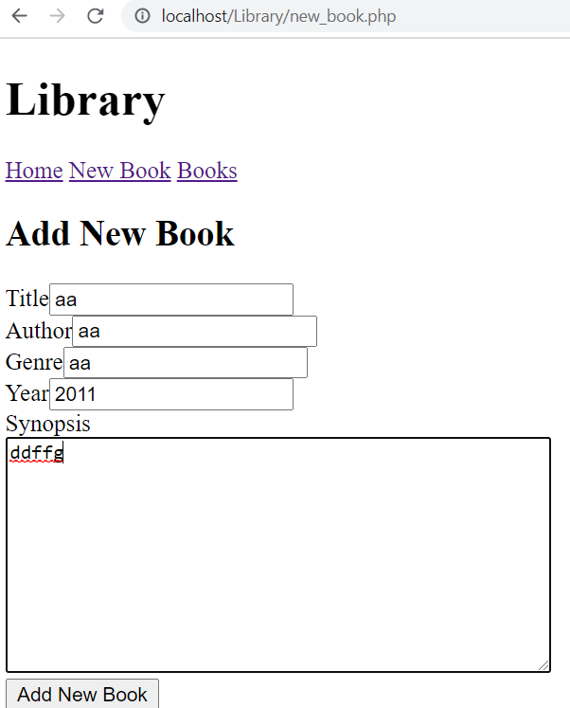

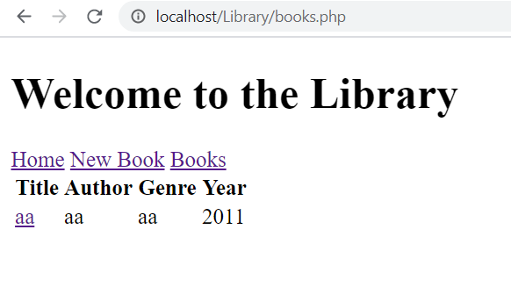

Click on the link generated for title to know the description of the Book

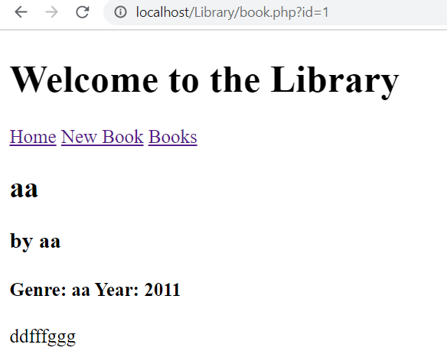 This URL includes Query String

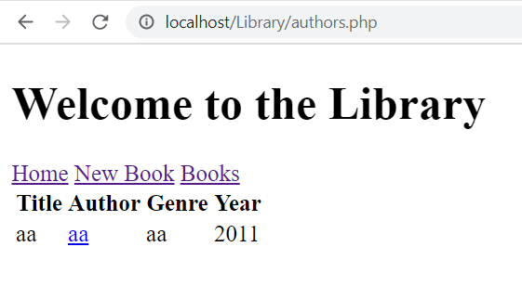

To search the books written by a particular author click on link generated under author

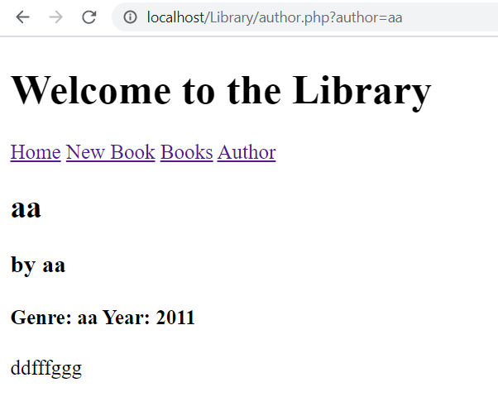This URL includes Query String

A query string is a part of a uniform resource locator that assigns values to specified parameters. A query string commonly includes fields added to a base URL by a Web browser or other client application, for example as part of an HTML form. [Wikipedia](https://en.wikipedia.org/wiki/Query_string)

Step 4: we have following files in Library folder

1. New_Book.php is a form to add new books in Library database created by the above script
2. Books.php will display all the details entered in the database with a hyperlink under the title of the book.if a user wants to know details of a particular book ,they can click on the title of the book .
3. Authors.php will display all the details entered in the database with a hyperlink under the author of the book.if a user wants to know all the books written by this particular Author , they can click on the Author of the book .
4. As shown in the above diagram that Process_new_book ,Book.php,Author.php are the supporting scripts.
5. Supporting scripts depends on the actions of users like Process_new _Book will work automatically if user click submit button to add new book.
6. Book.php will work automatically on the basis of particular value passed by user in Books.php
7. Author.php will work automatically on the basis of particular value passed by user in Authors.php